Lab Assignment 3.3: Application for TGNPDCL
Name: Suvikhyath Thirunahari
Program: M. Tech
Roll No.: 2503B05202
Course Code: 24CS002PC215
Course Title: AI Assisted Problem Solving Using Python
Date: 02-11-2025
Objective
The objective of this lab is to build a Python-based billing application for TGNPDCL (Telangana Northern Power Distribution Company Limited). The application should calculate the total electricity bill based on energy consumption, customer type, and relevant fixed and duty charges. AI tools such as GitHub Copilot or Google Gemini will be used to assist in generating and refining the Python code.

Tools and Environment
1. Visual Studio Code with GitHub Copilot extension
2. Google Colab with Gemini
3. Python 3.x environment
4. Sample household power bill (for verification)

Task Description
Develop a Python program that reads customer details and calculates electricity charges for TGNPDCL. The program should include calculation of the following components:
- EC – Energy Charges (based on units consumed and customer type)
- FC – Fixed Charges (constant or customer-based)
- CC – Customer Charges (fixed service-related cost)
- ED – Electricity Duty Charges (percentage of total)
- Total Bill – Sum of all the above components

Step-by-Step Procedure
- Open Google Colab and create a new Python file.
- Use an AI tool (Gemini) to generate a basic structure for reading input values (PU, CU, customer type).
- Define logic for computing EC, FC, CC, and ED based on customer type (domestic, commercial, industrial).
- Compute total bill amount and print a detailed breakdown of all charges.
- Test the program with values from your household power bill.
- Verify the total with the real bill to ensure calculation accuracy.

Python Code
def energy_charge_domestic(units):
"""Return energy charge (₹) for given units using LT-I slab structure."""

if units <= 50:
return units * 1.95
if units <= 100:

return 50 * 1.95 + (units - 50) * 3.10
if units <= 200:

if units <= 100:
return 50 * 1.95 + 50 * 3.10
return 100 * 3.40 + (units - 100) * 4.80
if units <= 200:
return 200 * 5.10
if units <= 300:
return 200 * 5.10 + (units - 200) * 7.70
if units <= 400:
return 200 * 5.10 + 100 * 7.70 + (units - 300) * 9.00
if units <= 800:
return 200 * 5.10 + 100 * 7.70 + 100 * 9.00 + (units - 400) * 9.50
# above 800
return 200 * 5.10 + 100 * 7.70 + 100 * 9.00 + 400 * 9.50 + (units - 800) * 10.00

def energy_charge_commercial(units):
"""Simplified commercial slab calculation (LT-II) from tariff table."""
if units <= 50:
return units * 7.00
if units <= 100:
# Use 0-100 @8.50 per table
return units * 8.50
if units <= 300:
return 100 * 8.50 + (units - 100) * 9.90
if units <= 500:
return 100 * 8.50 + 200 * 9.90 + (units - 300) * 10.40
return 100 * 8.50 + 200 * 9.90 + 200 * 10.40 + (units - 500) * 11.00

def energy_charge_industrial(units):
"""Industrial - for most small industry categories table gives flat per unit (example: 7.70)."""

return units * 7.70

def calculate_bill(units, customer_type):
ed_per_unit = 0.06
customer_type = customer_type.strip().lower()

if customer_type == "domestic":
energy = energy_charge_domestic(units)
fixed_charge = 10.0
elif customer_type == "commercial":
energy = energy_charge_commercial(units)
fixed_charge = 60.0 if units <= 50 else 70.0
elif customer_type == "industrial":
energy = energy_charge_industrial(units)
fixed_charge = 75.0
else:
raise ValueError("Invalid customer type. Use Domestic/Commercial/Industrial.")

customer_charges = 25.0
electricity_duty = units * ed_per_unit
total_bill = energy + fixed_charge + customer_charges + electricity_duty
print("\n----- TGNPDCL Electricity Bill -----")
print(f"Customer Type : {customer_type.capitalize()}")
print(f"Units Consumed : {units}")
print(f"Energy Charges (EC) : ₹{energy:.2f}")
print(f"Fixed/Demand Charge : ₹{fixed_charge:.2f}")
print(f"Customer Charges(CC): ₹{customer_charges:.2f}")
print(f"Electricity Duty(ED): ₹{electricity_duty:.2f} (₹{ed_per_unit:.2f}/unit)")
print(f"Total Bill Amount : ₹{total_bill:.2f}")
return total_bill

# --- run as script ---
if __name__ == "__main__":
try:
u = float(input("Enter units consumed (kWh) for the month: ").strip())
c = input("Enter customer type (Domestic/Commercial/Industrial): ").strip()
calculate_bill(u, c)
except Exception as e:
print("Error:", e)

Output
For example, if the customer type is Domestic and units consumed are 250:
Enter units consumed (kWh) for the month: 250
Enter customer type (Domestic/Commercial/Industrial): domestic
----- TGNPDCL Electricity Bill -----
Customer Type : Domestic
Units Consumed : 250.0
Energy Charges (EC) : ₹1405.00
Fixed/Demand Charge : ₹10.00
Customer Charges(CC): ₹25.00
Electricity Duty(ED): ₹15.00 (₹0.06/unit)
Total Bill Amount : ₹1455.00

Screenshots
• AI-generated code suggestion in Gemini
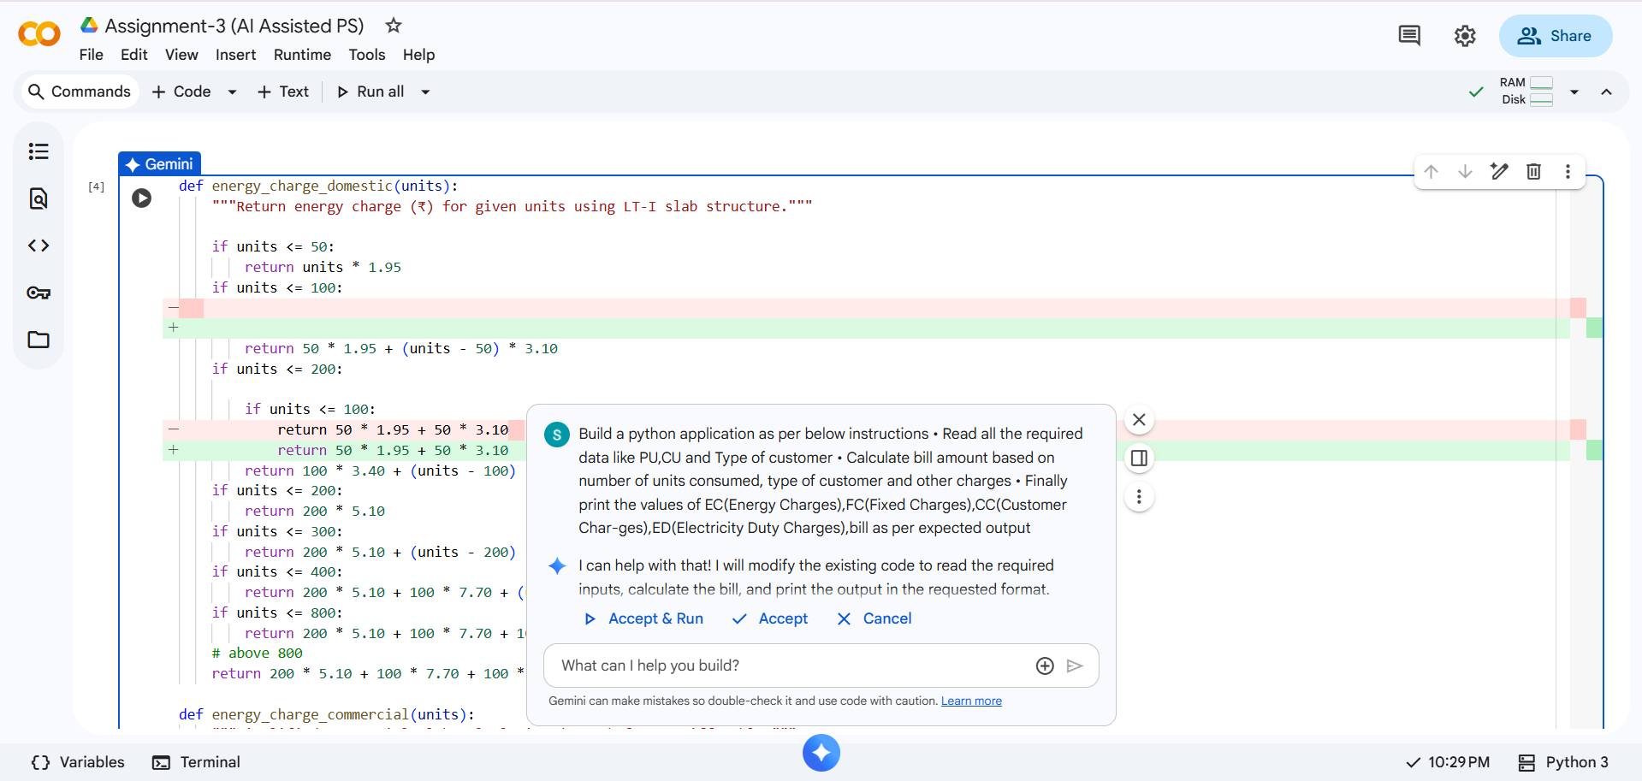
• Final program running successfully in Colab
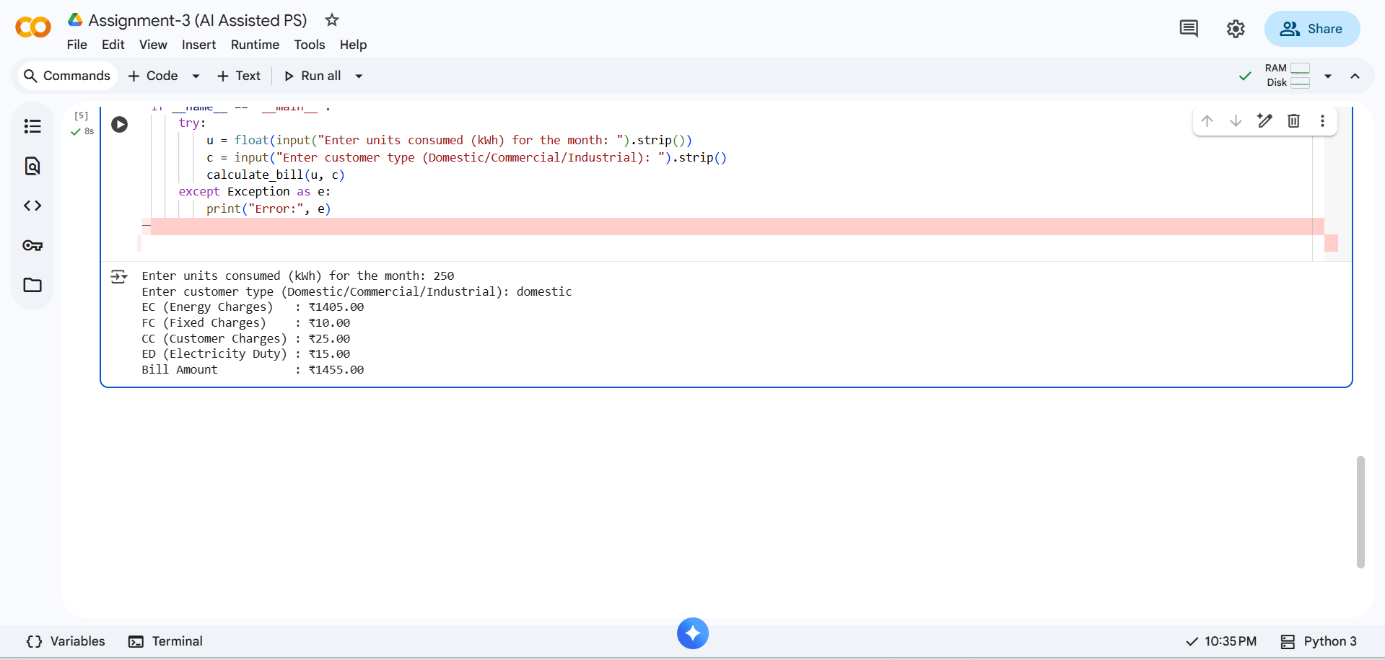
• Output window showing bill breakdown
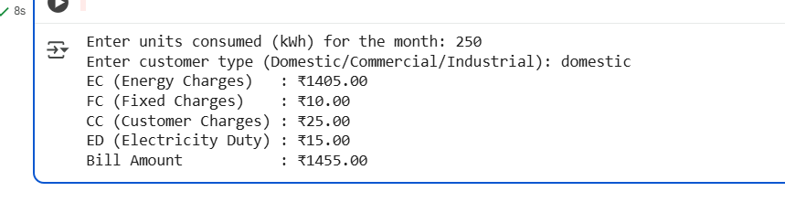

Analysis and Discussion
The AI tools significantly assisted in creating the bill calculation logic by auto-suggesting function structures, improving syntax, and providing efficient handling of conditions for different customer types. The logic was refined manually to ensure accuracy as per TGNPDCL’s expected billing format.

Conclusion
The TGNPDCL billing application demonstrates how AI-assisted coding can streamline real-world problem-solving using Python. Tools like GitHub Copilot and Gemini proved valuable in generating accurate and optimized code structures, reducing development time while maintaining correctness and readability.

